Exercise 1: Inventory Management System
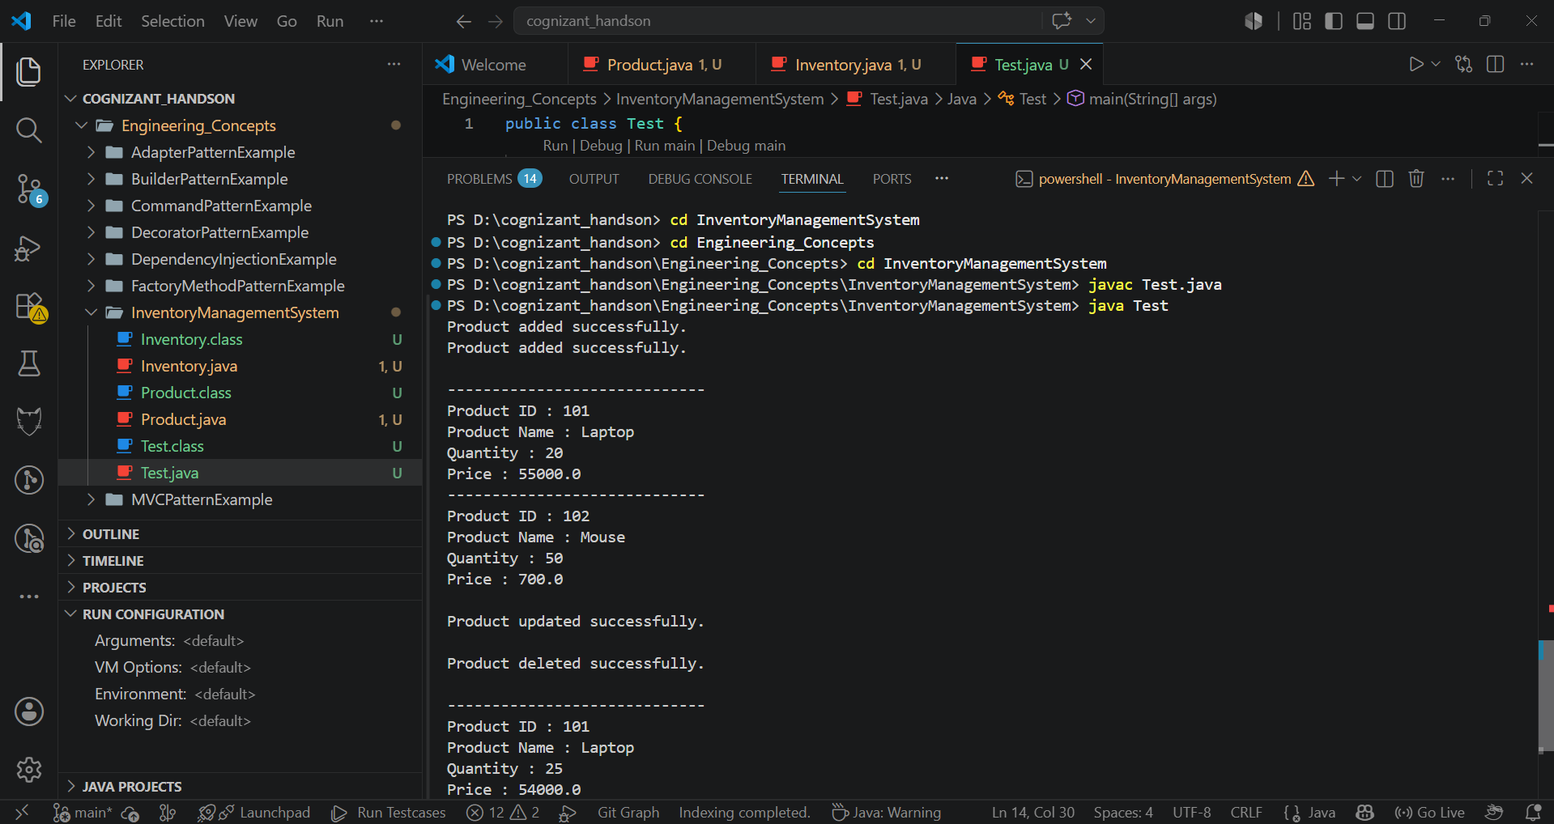
Exercise 2: E-commerce Platform Search Function
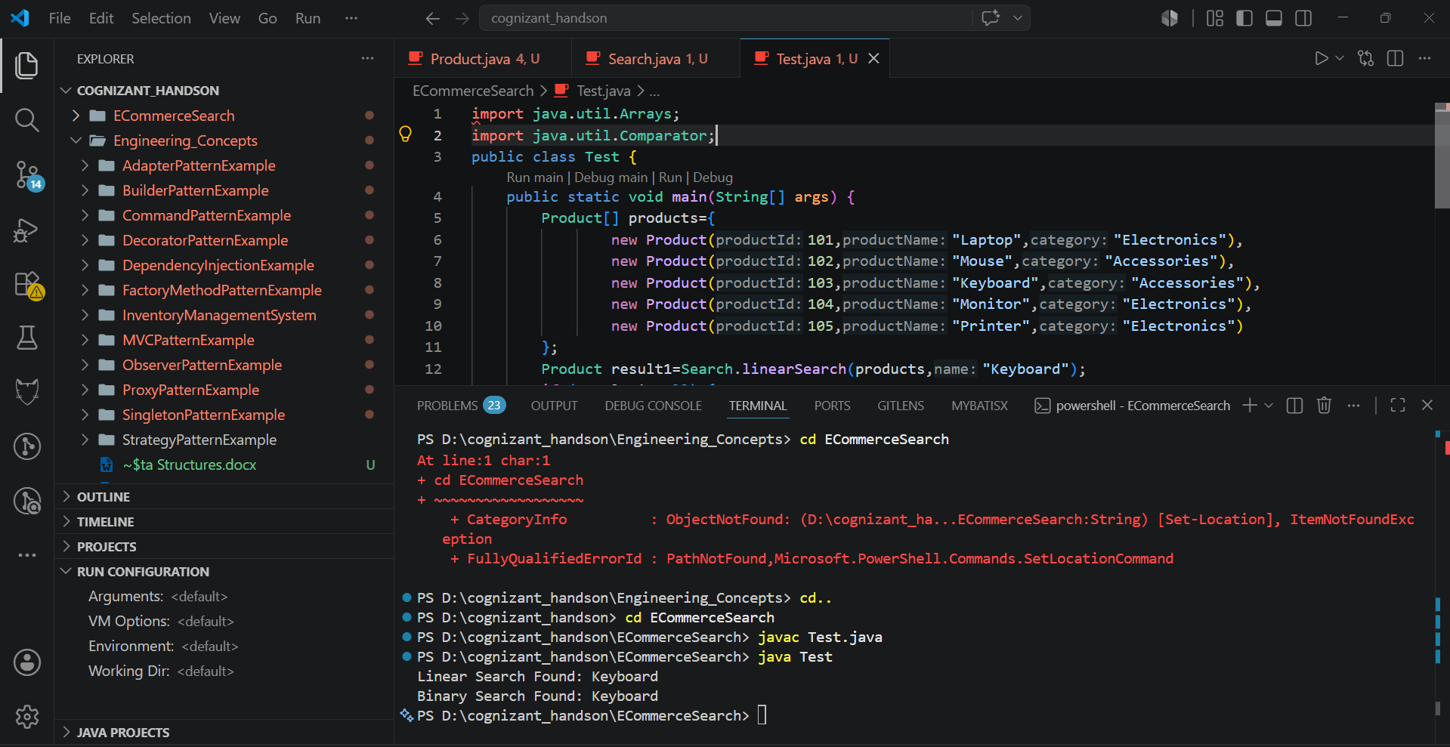
Exercise 3: Sorting Customer Orders
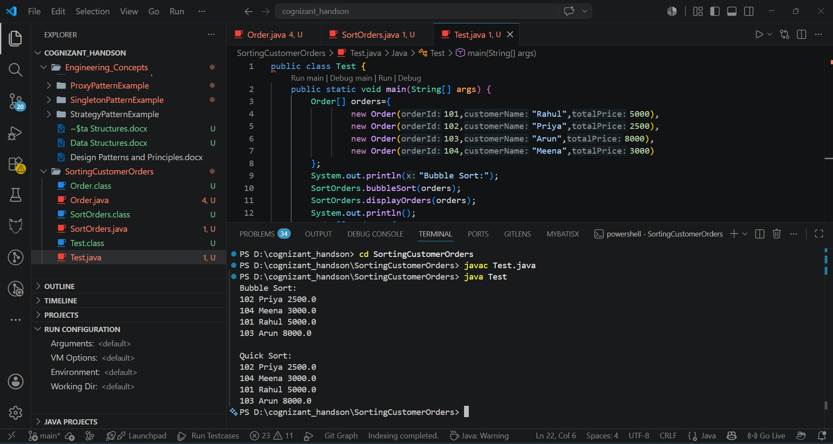

Exercise 4: Employee Management System
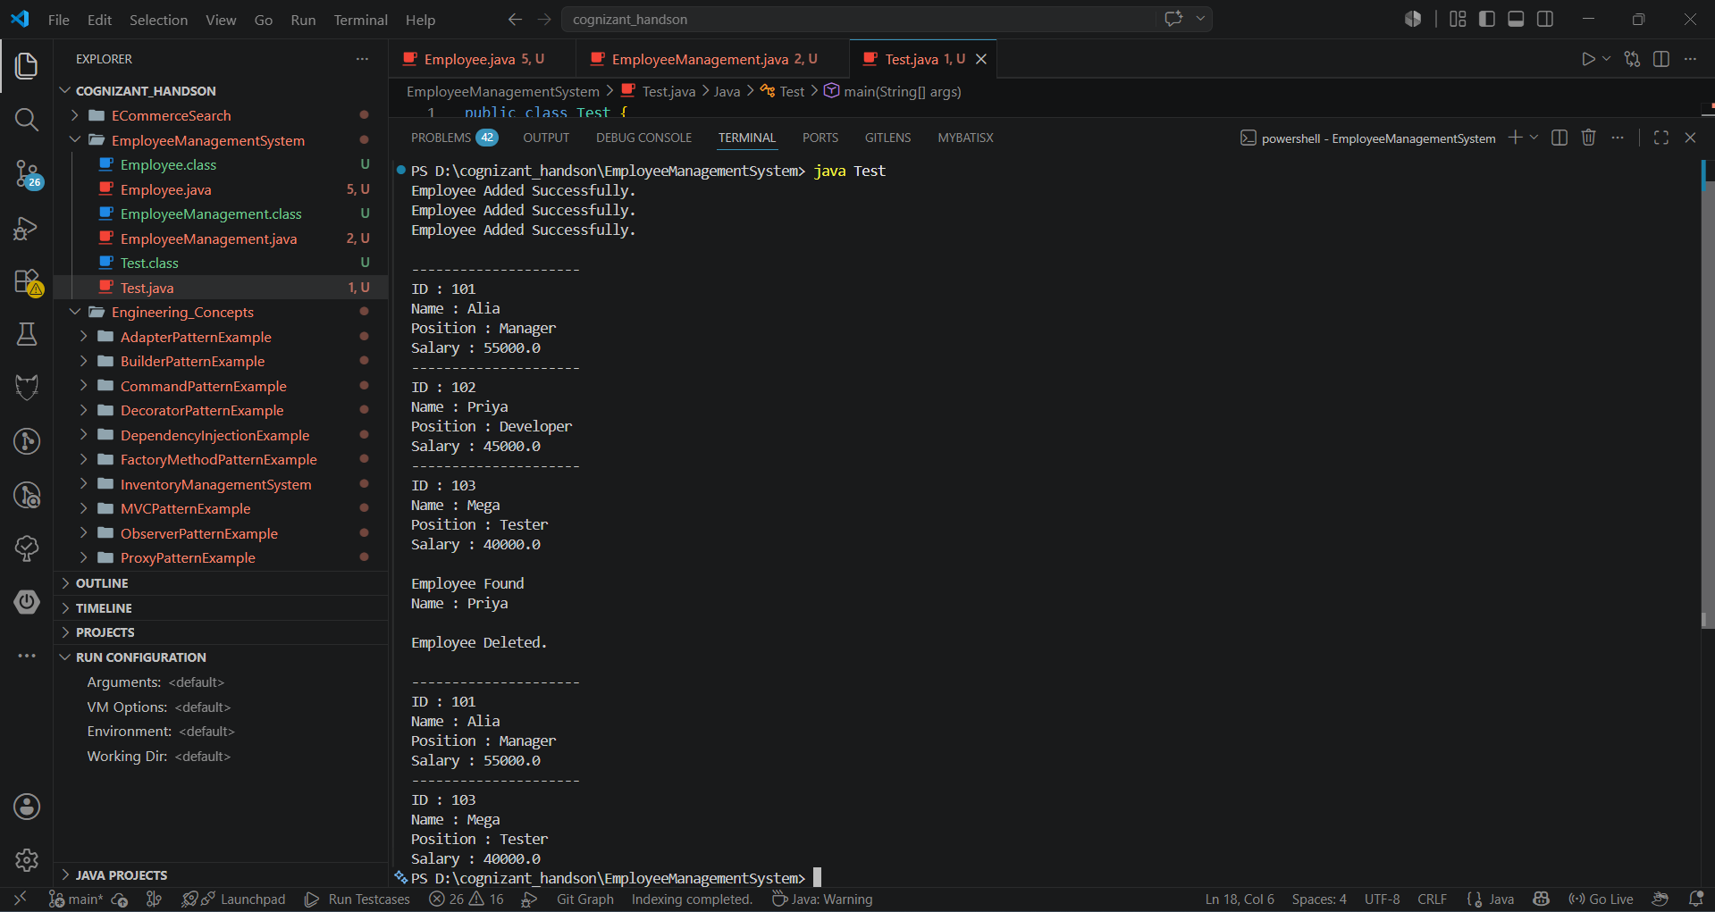
Exercise 5: Task Management System
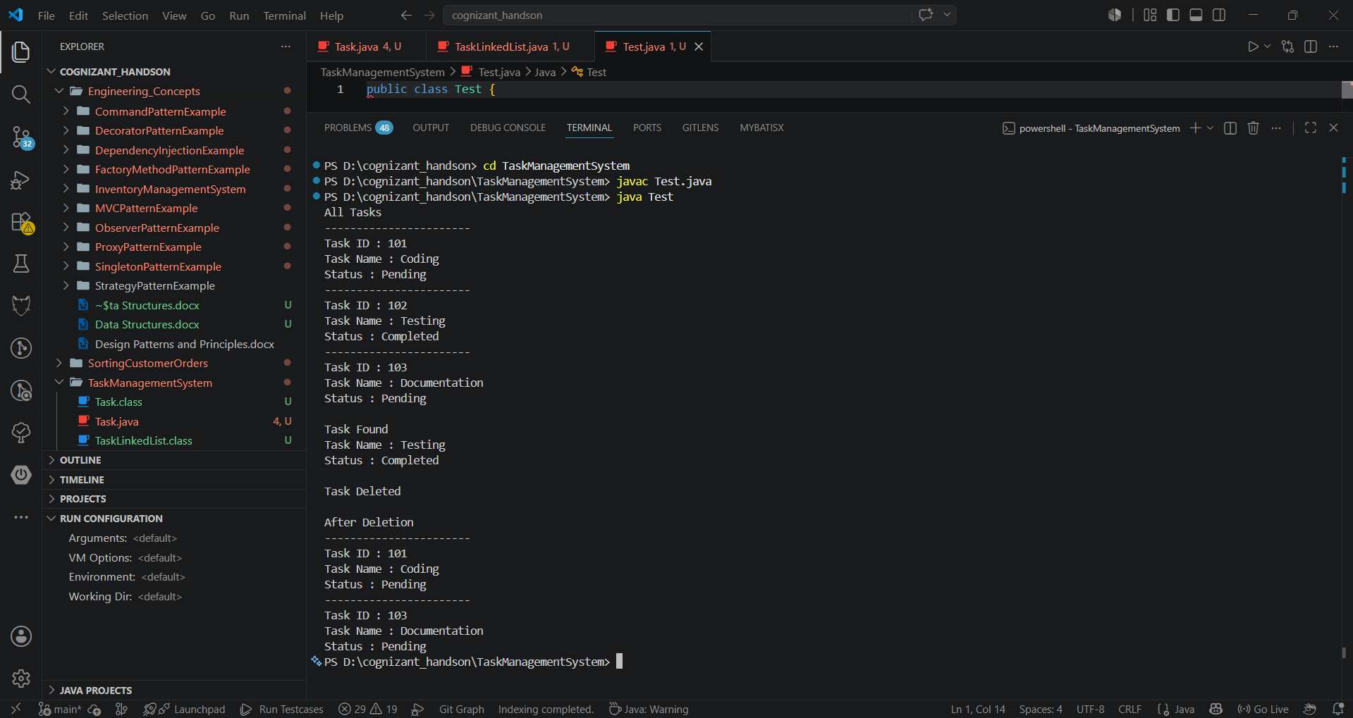
Exercise 6: Library Management System
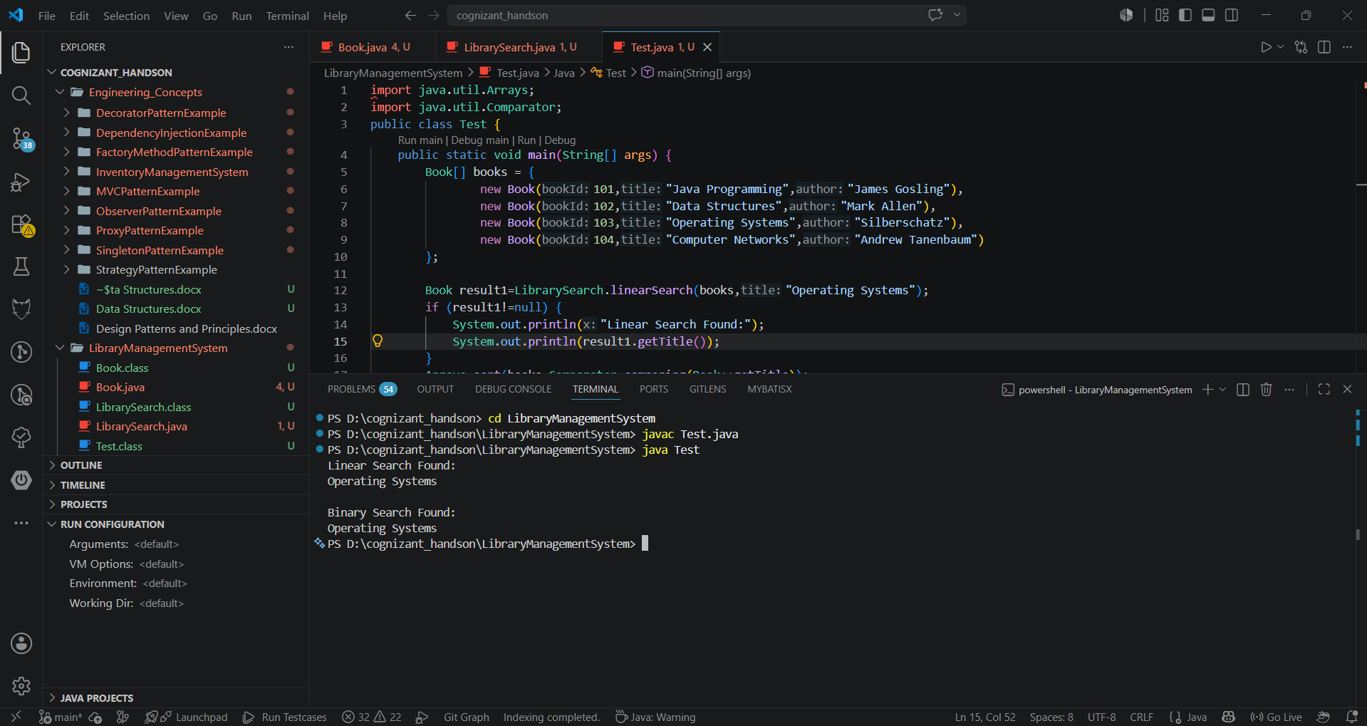

Exercise 7: Financial Forecasting
